**VISVESVARAYA TECHNOLOGICAL UNIVERSITY**

**“JnanaSangama”, Belgaum -590014, Karnataka.**



**LAB REPORT**

**on**

**COMPUTER NETWORKS**

***Submitted by***

**Devanshi Slathia**

***in partial fulfillment for the award of the degree of***

**BACHELOR OF ENGINEERING**

***in***

**COMPUTER SCIENCE AND ENGINEERING**



**B.M.S. COLLEGE OF ENGINEERING**

**(Autonomous Institution under VTU)**

**BENGALURU-560019**

**Sep 2024-Jan 2025**

**B. M. S. College of Engineering,**

**Bull Temple Road, Bangalore 560019**

(Affiliated To Visvesvaraya Technological University, Belgaum)

**Department of Computer Science and Engineering**



**CERTIFICATE**

This is to certify that the Lab work entitled “**COMPUTER NETWORKS**” carried out by **Devanshi Slathia(1BM22CS083) ,** who is bonafide student of **B. M. S. College of Engineering.** It is in partial fulfillment for the award of **Bachelor of Engineering in Computer Science and Engineering** of the Visvesvaraya Technological University, Belgaum during the year 2024-25. The Lab report has been approved as it satisfies the academic requirements in respect of **Computer Networks Lab - (23CS5PCCON)** work prescribed for the said degree.

**Dr. Nandhini Vineeth Dr. Kavitha Sooda**

Associate Professor, Professor and Head,

Department of CSE, Department of CSE

BMSCE, Bengaluru BMSCE, Bengaluru

**INDEX**

CYCLE 1

| **Sl. No.** | **Date** | **Experiment Title** | **Page No.** |
| --- | --- | --- | --- |
| 1 | 9-10-24 | Create a topology and simulate sending a simple PDU from source to destination using hub and switch as connecting devices and demonstrate ping message. | 1-4 |
| 2 | 16-10-24 | Configure IP address to routers in packet tracer. Explore the following messages: ping responses, destination unreachable, request timed out, reply | 4-8 |
| 3 | 23-10-24 | Configure default route, static route to the Router | 8-16 |
| 4 | 13-11-24 | Configure DHCP within a LAN and outside LAN. | 16-20 |
| 5 | 21-11-24 | Configure RIP routing Protocol in Routers | 20-24 |
| 6 | 21-11-24 | Configure OSPF routing protocol | 24-28 |
| 7 | 21-11-24 | Demonstrate the TTL/ Life of a Packet | 28-30 |
| 8 | 27-11-24 | Configure Web Server, DNS within a LAN. | 30-34 |
| 9 | 18-12-24 | To construct simple LAN and understand the concept and operation of Address Resolution Protocol (ARP) | 34-38 |
| 10 | 18-12-24 | To understand the operation of TELNET by accessing the router in server room from a PC in IT office. | 38-42 |
| 11 | 18-12-24 | To construct a VLAN and make the PC’s communicate among a VLAN | 42-50 |
| 12 | 18-12-24 | To construct a WLAN and make the nodes communicate wirelessly | 50-54 |

**INDEX**

CYCLE 2

| **Sl. No.** | **Date** | **Experiment Title** | **Page No.** |
| --- | --- | --- | --- |
| 1 | 1-1-25 | Write a program for error detecting code using CRC-CCITT (16-bits). | 54-58 |
| 2 | 1-1-25 | Write a program for congestion control using Leaky bucket algorithm. | 58-62 |
| 3 | 1-1-25 | Using TCP/IP sockets, write a client-server program to make client sending the file name and the server to send back the contents of the requested file if present. | 62-68 |
| 4 | 1-1-25 | Using UDP sockets, write a client-server program to make client sending the file name and the server to send back the contents of the requested file if present | 68-78 |

CN LAB

1BM22CS083

DEVANSHI SLATHIA

Lab 1

9-10-24

1Create a topology and simulate sending a simple PDU from source to destination using hub and switch as connecting devices and demonstrate ping message.

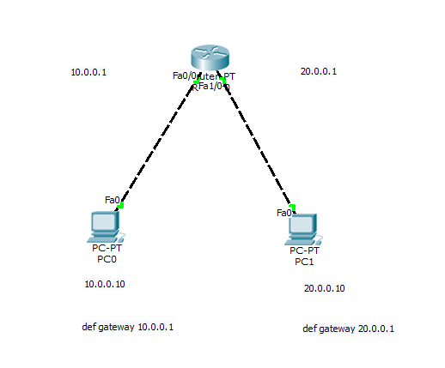

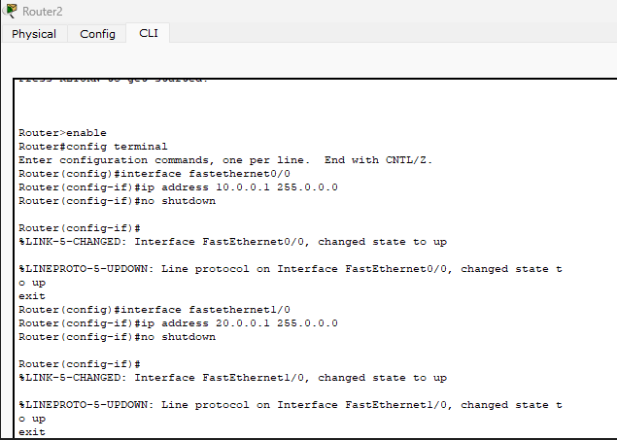

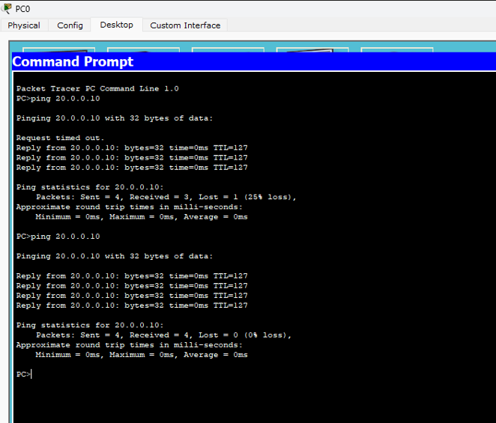

OBSERVATION

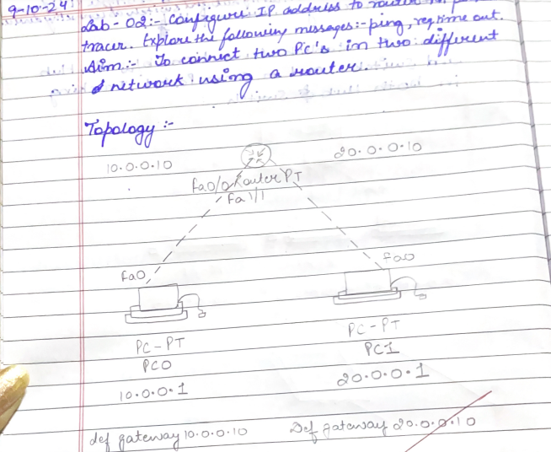

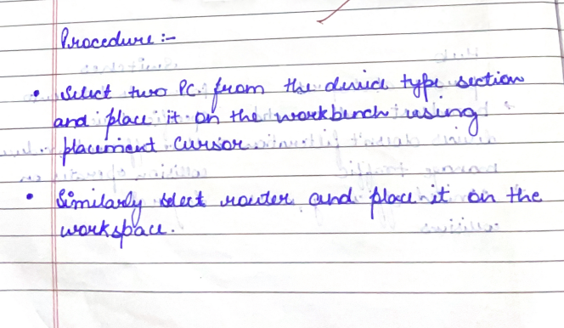

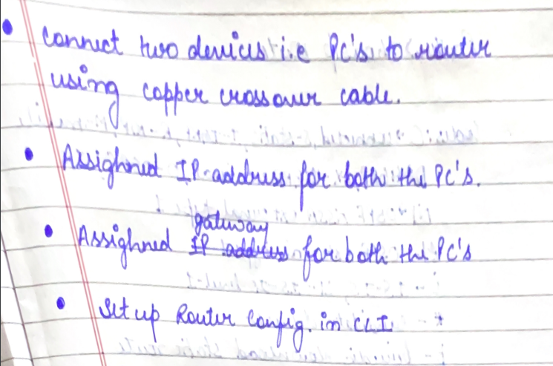

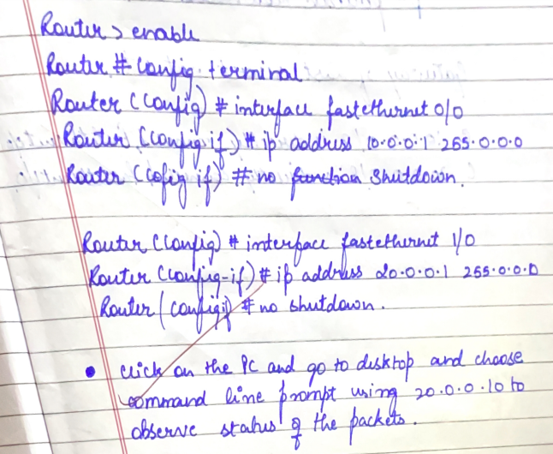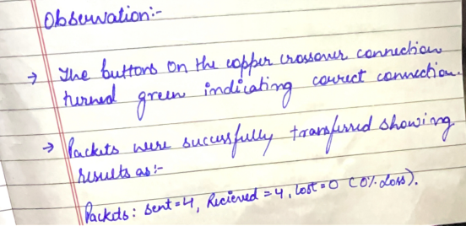

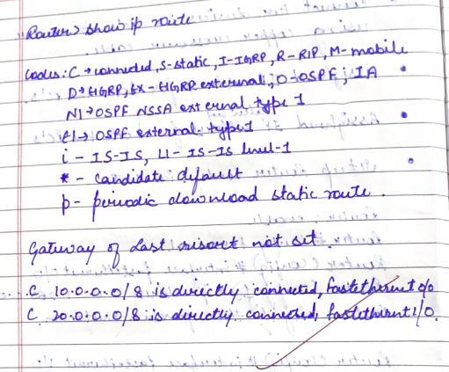

16-10-24

Lab-2

2.Configure IP address to routers in packet tracer. Explore the following messages: ping responses, destination unreachable, request timed out, reply

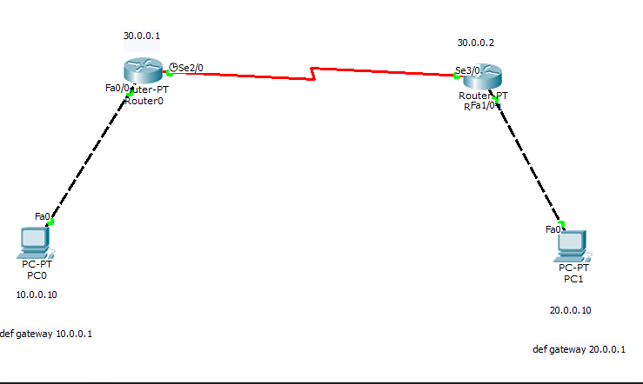

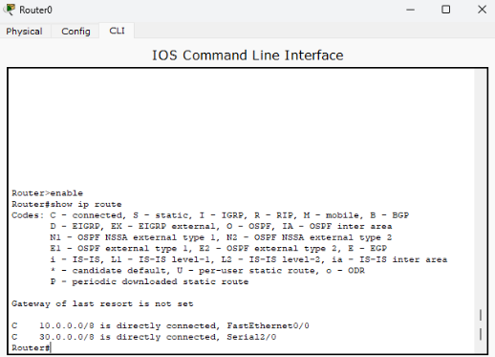

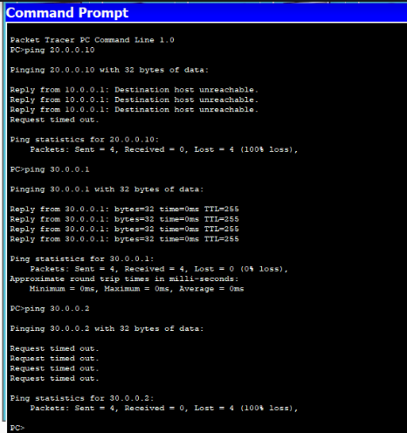

OBSERVATION

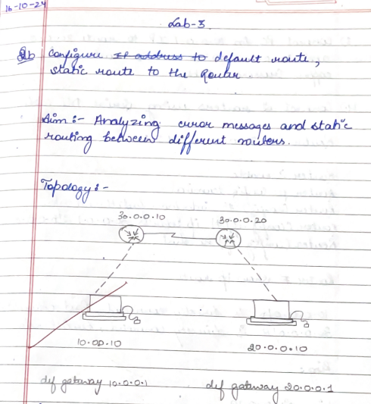

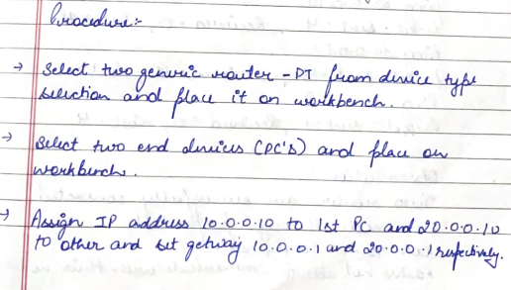

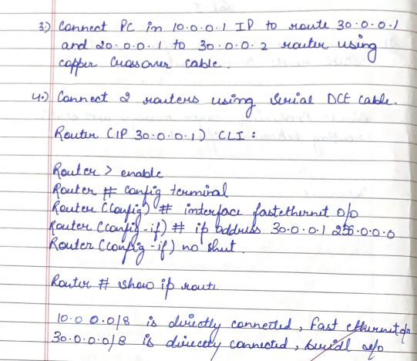

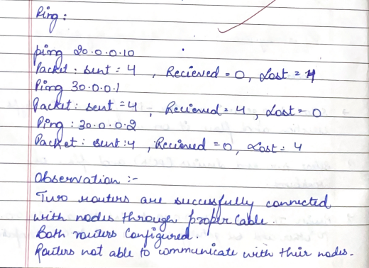

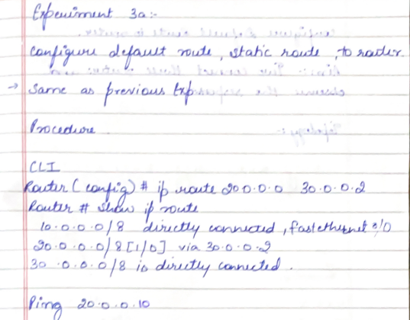

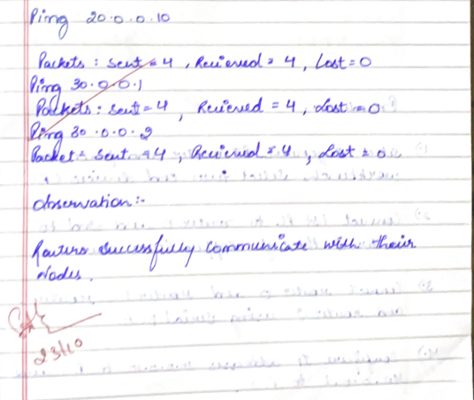

23-10-24

LAB-3

3.Configure default route, static route to the Router

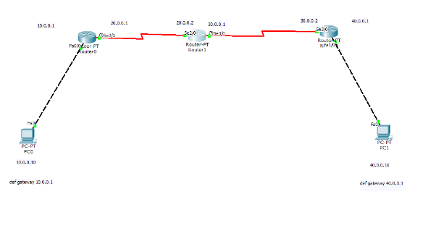

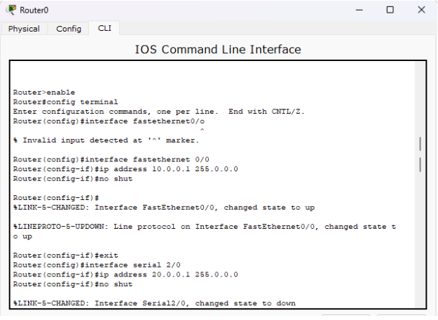

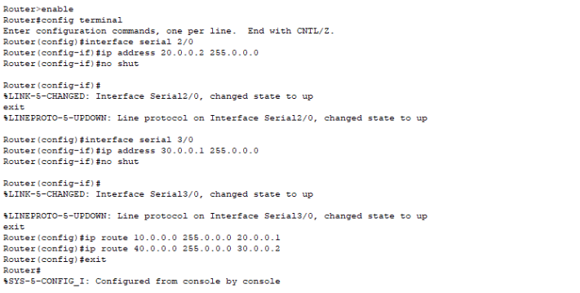

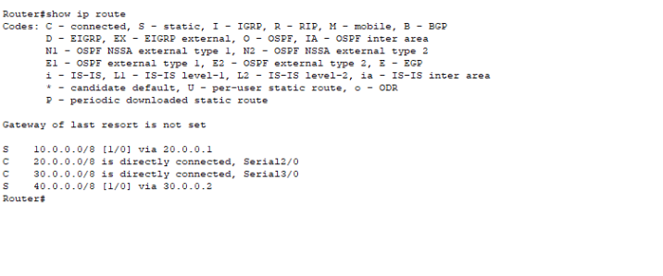

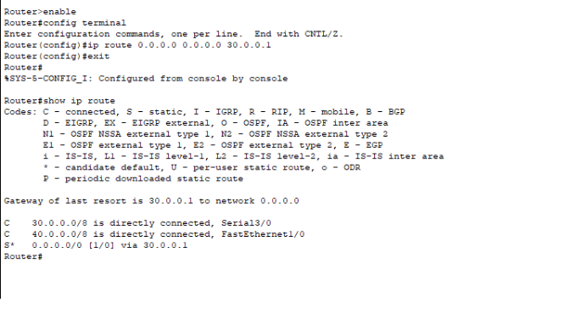

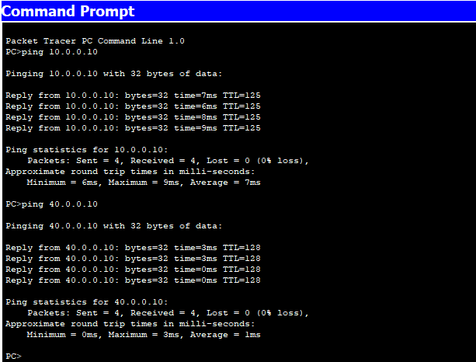

OBSERVATION

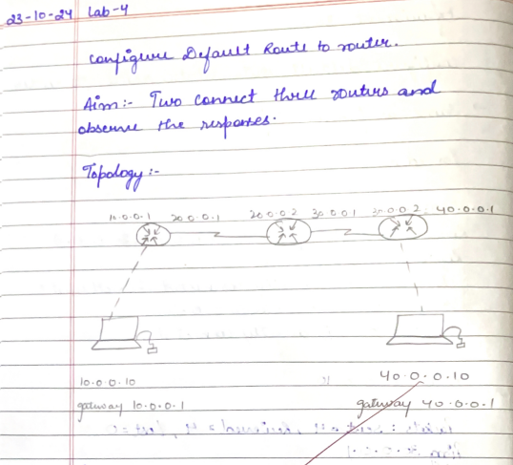

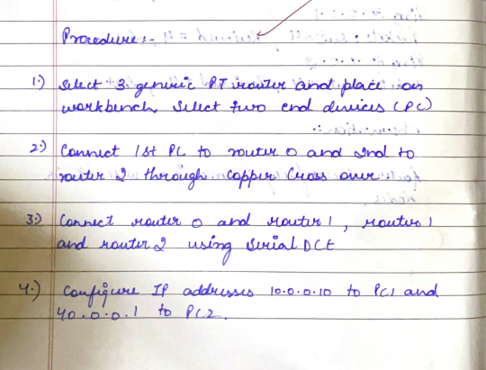

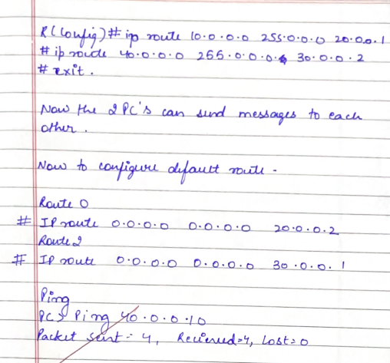

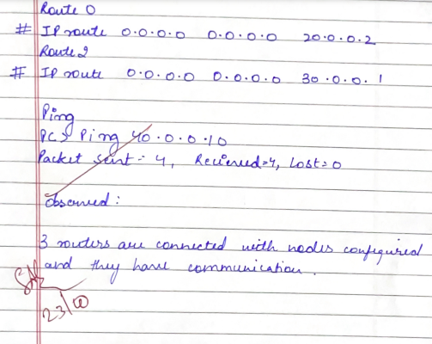

13-11-24

Lab-4

4.5 Configure DHCP within a LAN and outside LAN.

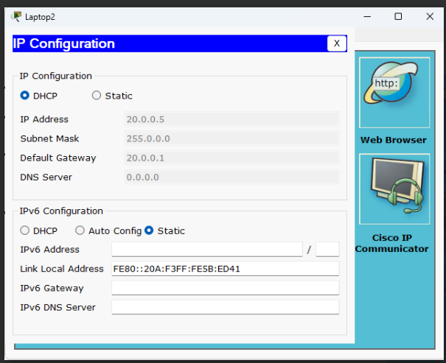

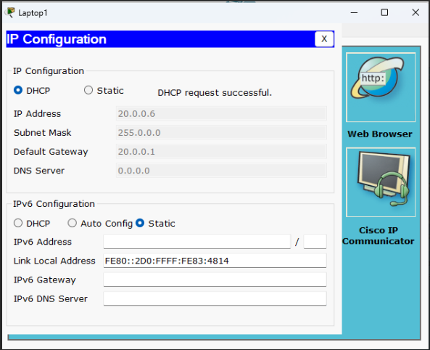

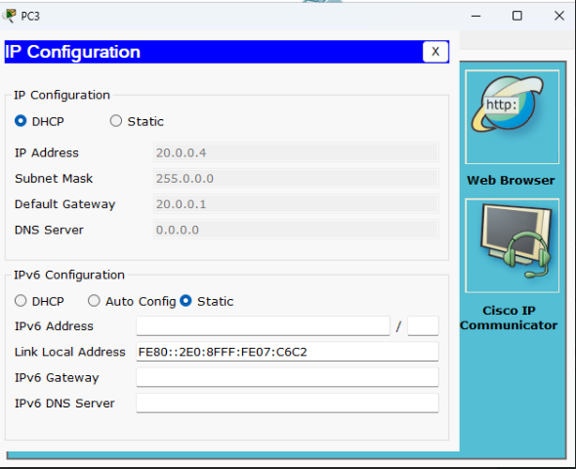

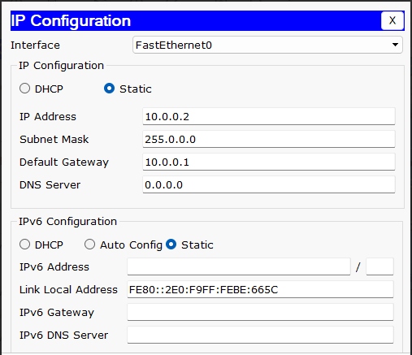

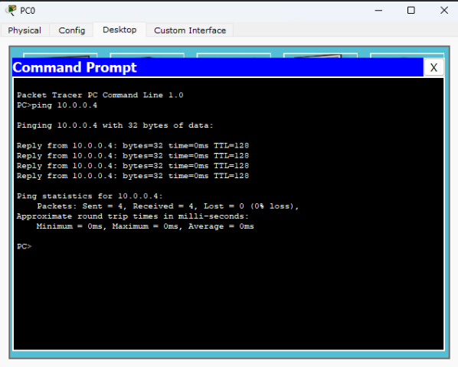

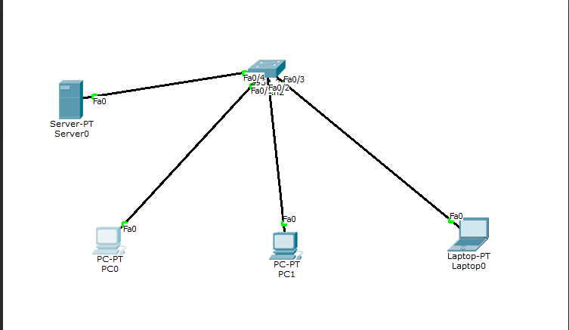

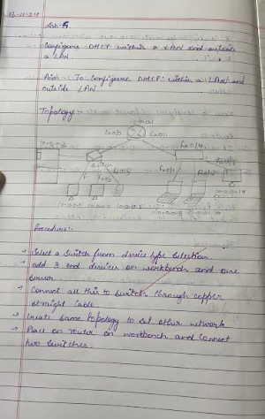

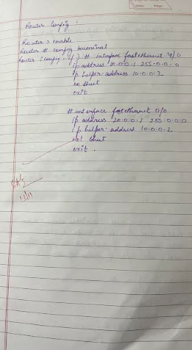

20-11-24

Lab - 5

5.Configure RIP routing Protocol in Routers

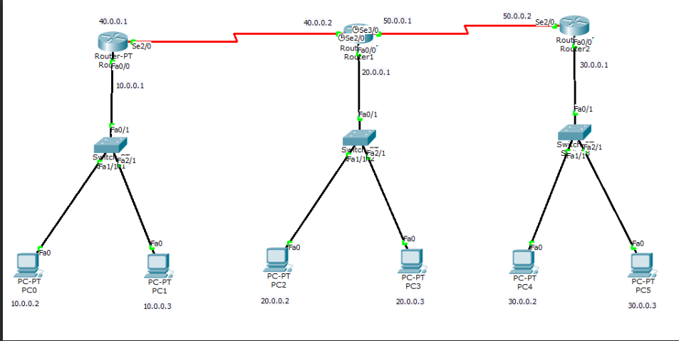

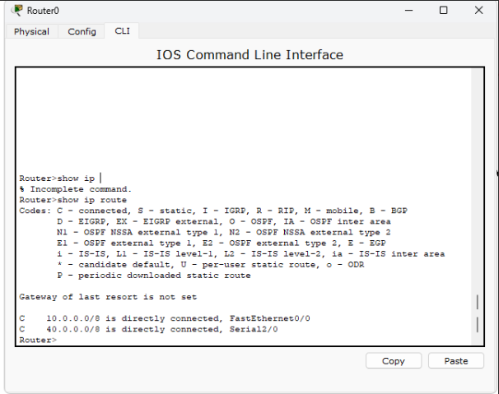

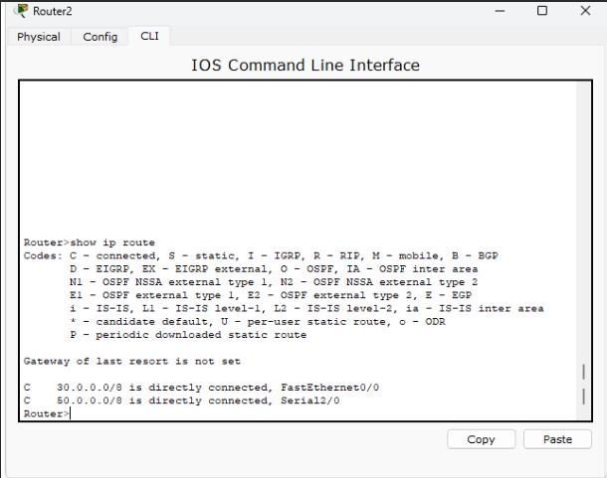

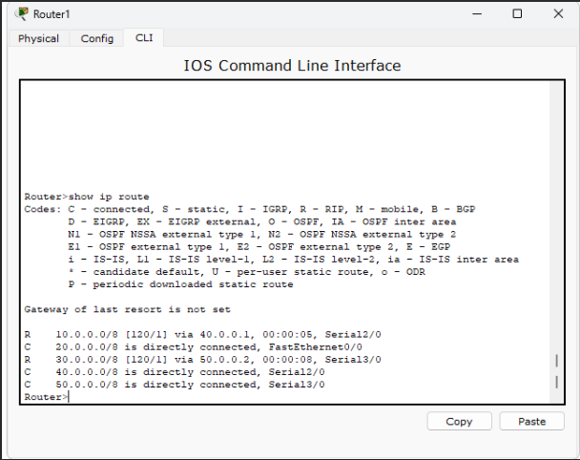

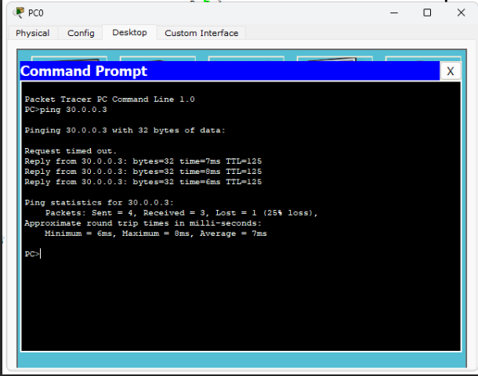

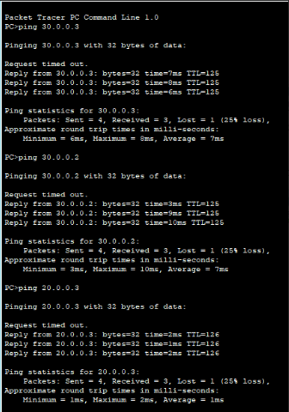

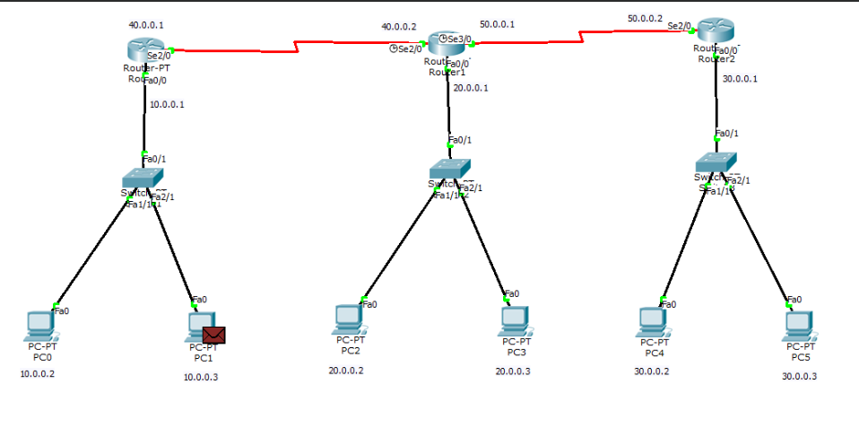

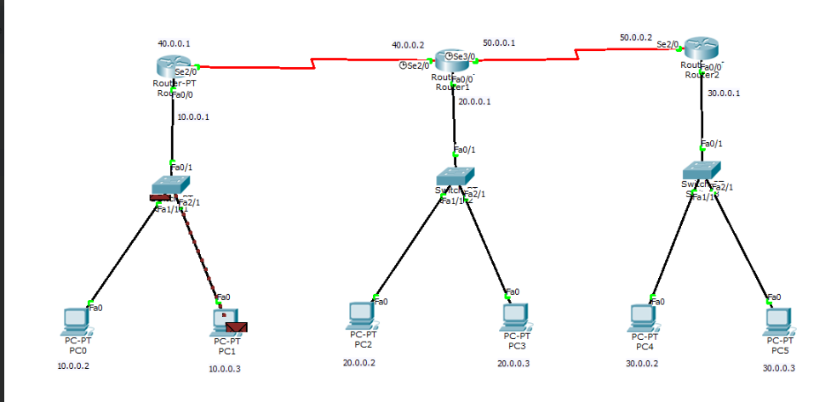

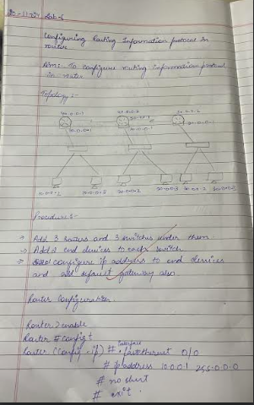

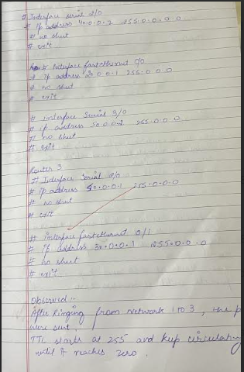

21-11-24

Lab-6

6. Configure OSPF routing protocol

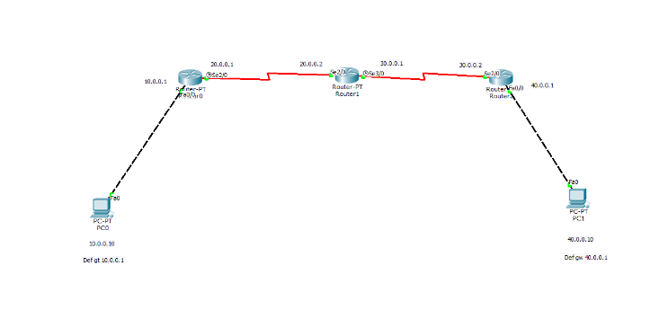

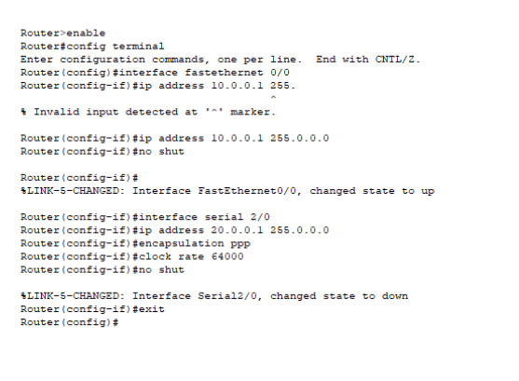

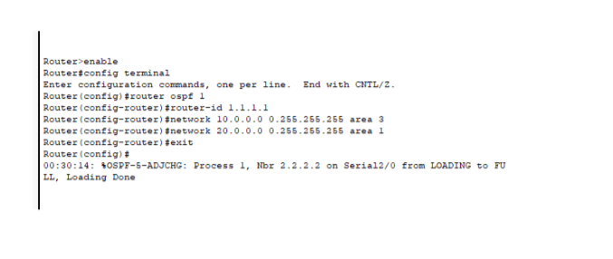

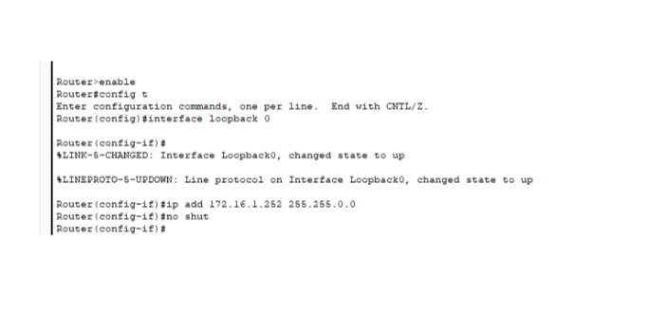

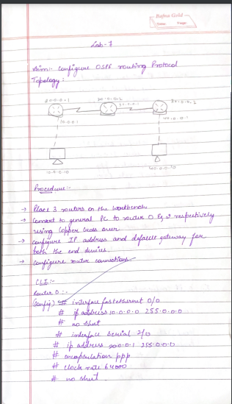

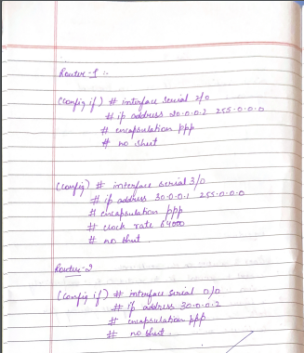

Lab-7

21-11-24

7.Demonstrate the TTL/ Life of a Packet

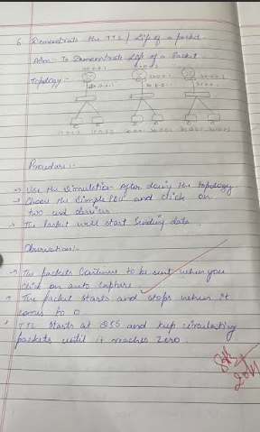

Lab-8

18-12-24

8.Configure Web Server, DNS within a LAN.

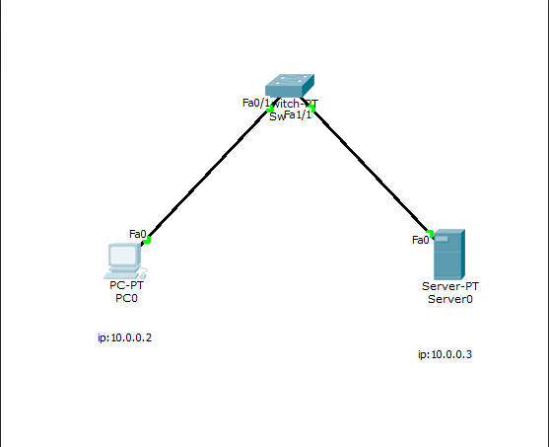

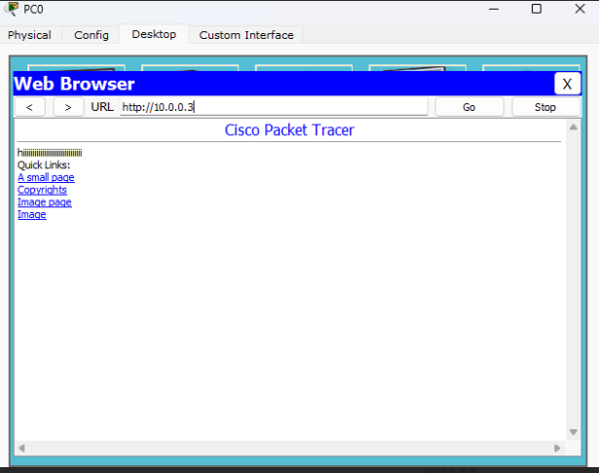

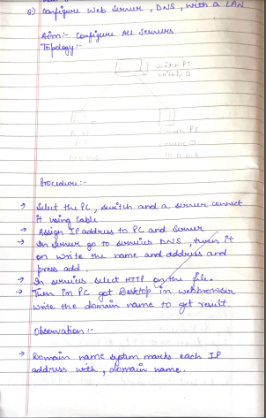

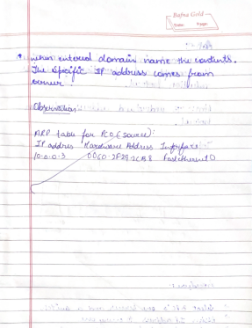

Lab-9

18-12-24

9.To construct simple LAN and understand the concept and operation of Address Resolution Protocol (ARP)

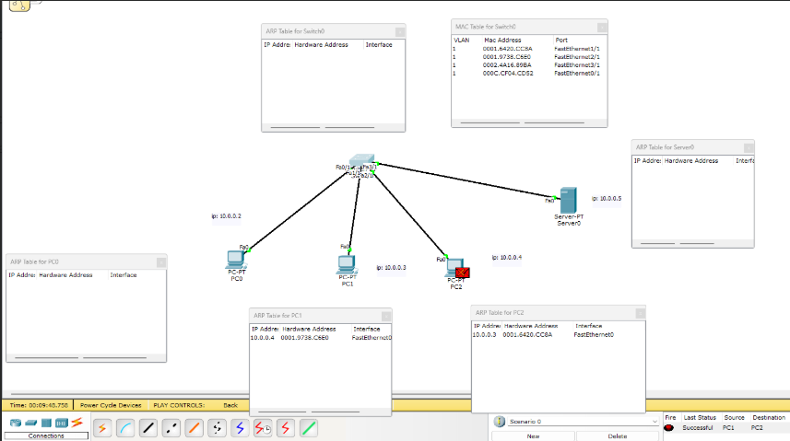

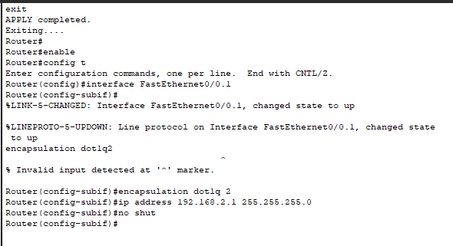

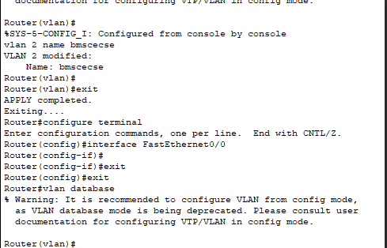

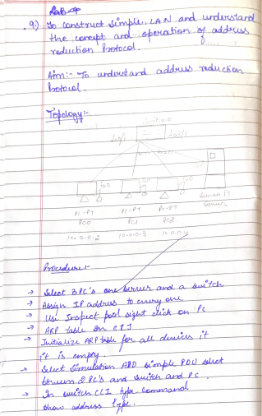

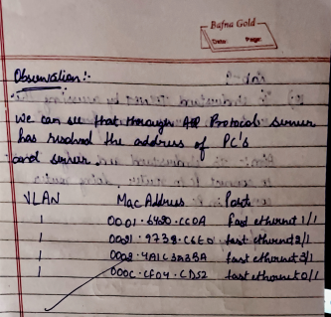

Lab-10

18-12-24

To understand the operation of TELNET by accessing the router in server room from a PC in IT office

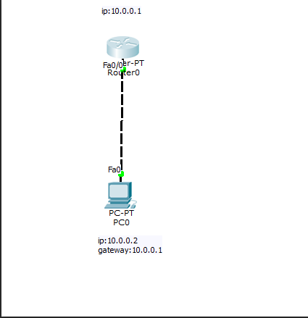

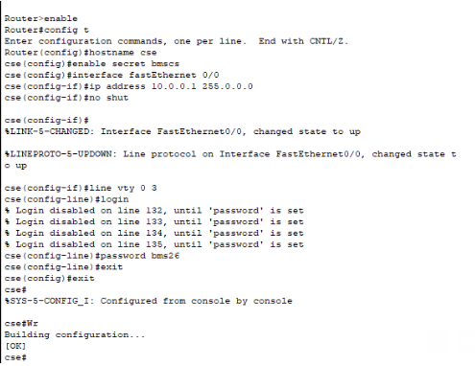

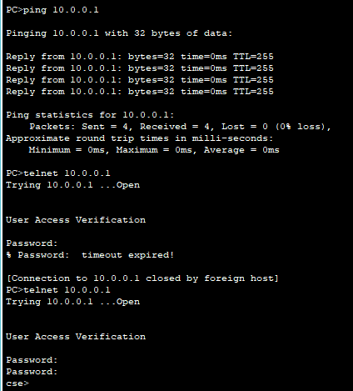

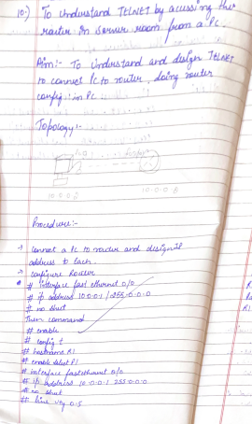

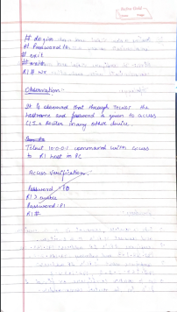

Lab-11

18-12-24

11.To construct a VLAN and make the PC’s communicate among a VLAN

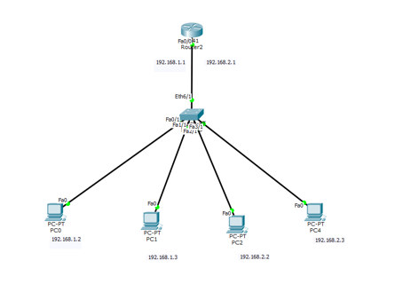

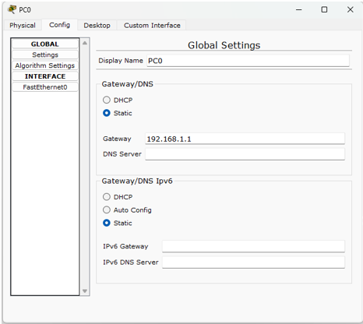

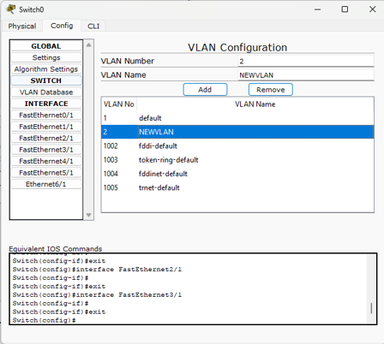

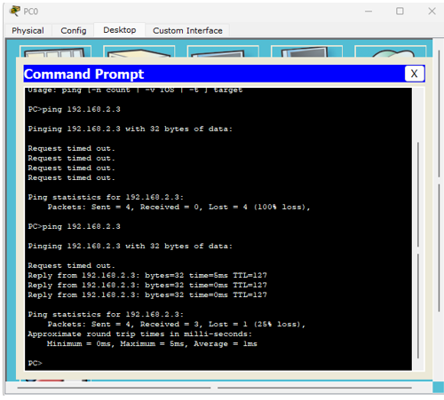

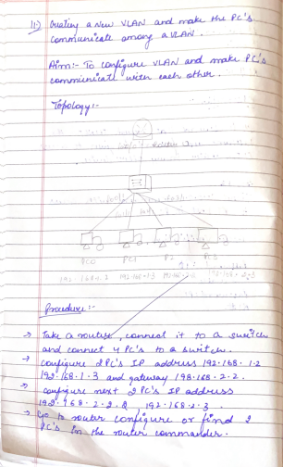

Lab-12

18-12-24

12.To construct a WLAN and make the nodes communicate wirelessly

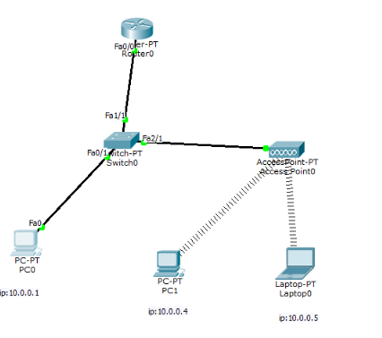

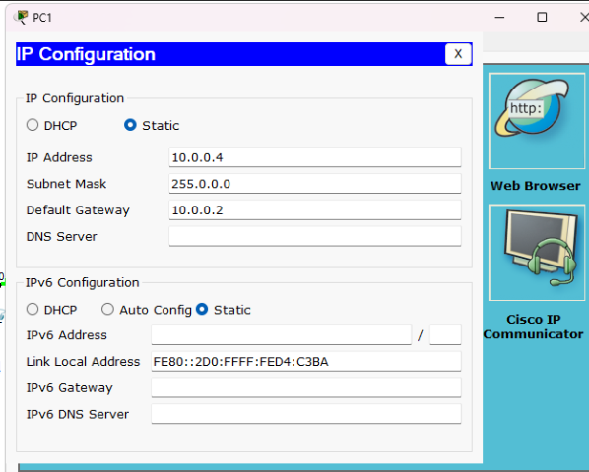

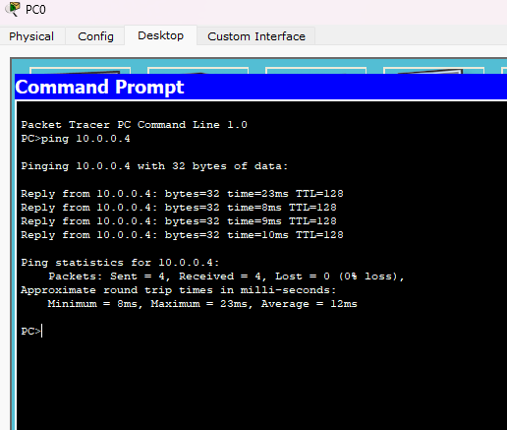

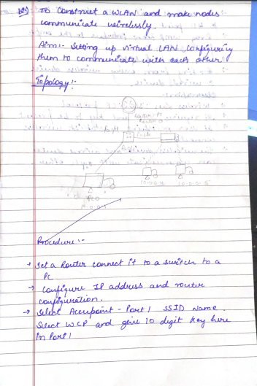

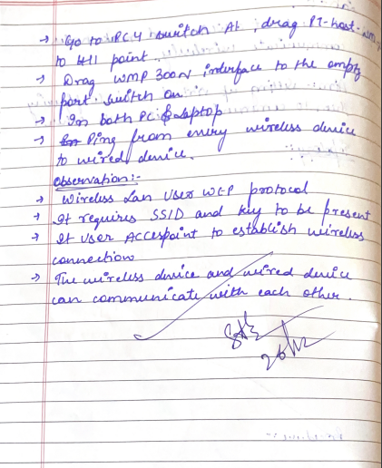

CYCLE 2 PROGRAMS:-

1.Write a program for error detecting code using CRC-CCITT (16-bits).

def crc_ccitt(data: bytes, poly: int = 0x1021, init_crc: int = 0xFFFF) -> int:

"""

Calculate the CRC-CCITT (16-bits) checksum.

:param data: The input data as a bytes object.

:param poly: The polynomial used for CRC calculation (default is 0x1021).

:param init_crc: The initial CRC value (default is 0xFFFF).

:return: The calculated CRC checksum as an integer.

"""

crc = init_crc

for byte in data:

crc ^= (byte << 8) # XOR byte into the upper 8 bits of CRC

for _ in range(8): # Process each bit

if crc & 0x8000: # Check if the highest bit is set

crc = (crc << 1) ^ poly

else:

crc = crc << 1

crc &= 0xFFFF # Ensure CRC remains 16-bit

return crc

# Example usage:

if __name__ == "__main__":

# Input data (as bytes)

data = b"Hello, CRC!"

# Calculate CRC-CCITT checksum

checksum = crc_ccitt(data)

# Print the result

print(f"Input data: {data}")

print(f"CRC-CCITT (16-bit) checksum: {checksum:04X}")

Output:-

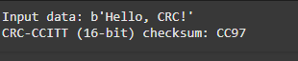

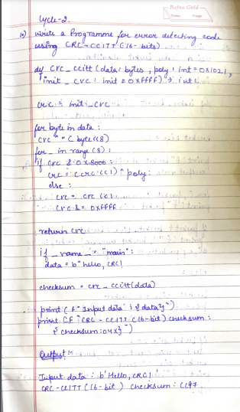

2.Write a program for congestion control using Leaky bucket algorithm.

import time

def leaky_bucket(input_packets, bucket_capacity, out_rate):

"""

Simulate the leaky bucket algorithm.

:param input_packets: A list of integers representing packet sizes.

:param bucket_capacity: The capacity of the bucket.

:param out_rate: The output rate (how many units can be sent per time unit).

"""

bucket_size = 0

print(f"Bucket capacity: {bucket_capacity}, Output rate: {out_rate}\n")

for i, packet in enumerate(input_packets):

print(f"Packet {i + 1}: {packet} units")

if packet + bucket_size > bucket_capacity:

print(f"\tBucket overflow! Packet {i + 1} of size {packet} is dropped.")

else:

bucket_size += packet

print(f"\tPacket {i + 1} added to the bucket. Current bucket size: {bucket_size}")

# Simulate output rate

if bucket_size > 0:

sent = min(out_rate, bucket_size)

bucket_size -= sent

print(f"\tSent {sent} units. Remaining bucket size: {bucket_size}")

else:

print("\tBucket is empty, nothing to send.")

time.sleep(1) # Simulate time delay

# Drain remaining packets in the bucket

while bucket_size > 0:

sent = min(out_rate, bucket_size)

bucket_size -= sent

print(f"\tSent {sent} units. Remaining bucket size: {bucket_size}")

time.sleep(1)

print("\nAll packets processed.")

# Example usage

if __name__ == "__main__":

input_packets = [10, 20, 30, 40, 10] # List of incoming packet sizes

bucket_capacity = 50 # Bucket capacity

out_rate = 20 # Output rate per time unit

leaky_bucket(input_packets, bucket_capacity, out_rate)

Output:-

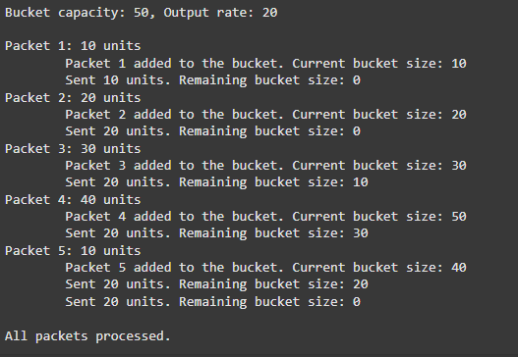

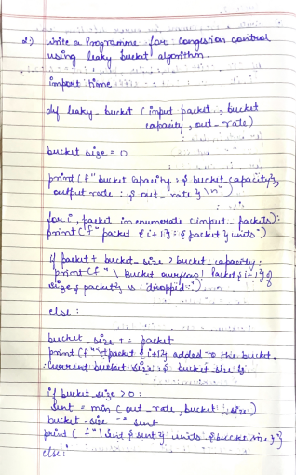

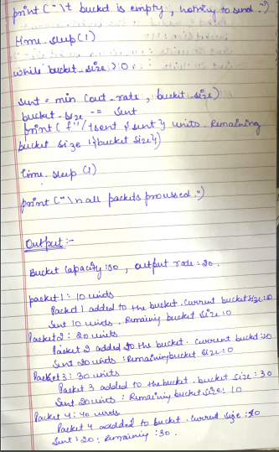

3.Using TCP/IP sockets, write a client-server program to make client sending the file name and the server to send back the contents of the requested file if present.

import socket

HOST = '127.0.0.1' # Localhost

PORT = 65432 # Port to listen on

def start_server():

with socket.socket(socket.AF_INET, socket.SOCK_STREAM) as server_socket:

server_socket.bind((HOST, PORT))

server_socket.listen()

print(f"Server listening on {HOST}:{PORT}")

while True:

conn, addr = server_socket.accept()

with conn:

print(f"Connected by {addr}")

# Receive the file name from the client

file_name = conn.recv(1024).decode()

print(f"Requested file: {file_name}")

try:

# Try to open and read the requested file

with open(file_name, 'r') as file:

file_contents = file.read()

conn.sendall(file_contents.encode())

print(f"File '{file_name}' sent successfully.")

except FileNotFoundError:

# Handle file not found

error_message = "Error: File not found."

conn.sendall(error_message.encode())

print(f"File '{file_name}' not found.")

if __name__ == "__main__":

start_server()

# Client Code

import socket

HOST = '127.0.0.1' # The server's hostname or IP address

PORT = 65432 # The port used by the server

def request_file():

with socket.socket(socket.AF_INET, socket.SOCK_STREAM) as client_socket:

client_socket.connect((HOST, PORT))

# Send the file name to the server

file_name = input("Enter the name of the file to request: ")

client_socket.sendall(file_name.encode())

# Receive the file contents from the server

file_contents = b""

while True:

data = client_socket.recv(4096)

if not data:

break

file_contents += data

print("\nServer response:")

print(file_contents.decode())

if __name__ == "__main__":

request_file()

Output



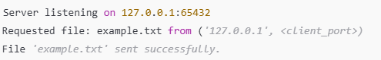

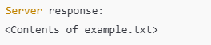

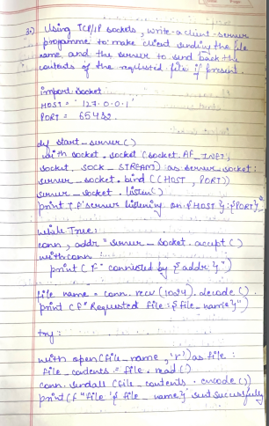

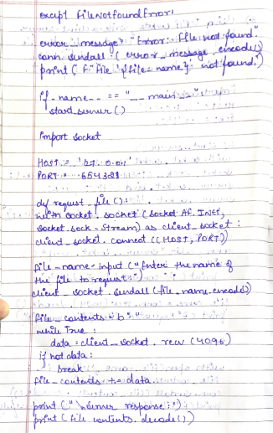

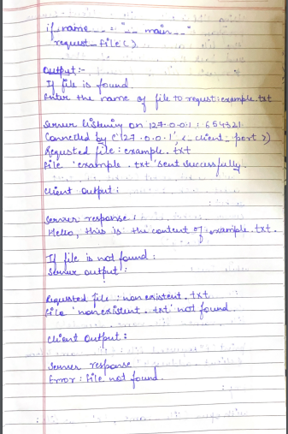

4.Using UDP sockets, write a client-server program to make client sending the file name and the server to send back the contents of the requested file if present.

import socket

HOST = '127.0.0.1' # Localhost

PORT = 65432 # Port to listen on

def start_server():

with socket.socket(socket.AF_INET, socket.SOCK_DGRAM) as server_socket:

server_socket.bind((HOST, PORT))

print(f"Server listening on {HOST}:{PORT}")

while True:

# Receive the file name from the client

file_name, client_address = server_socket.recvfrom(1024)

file_name = file_name.decode()

print(f"Requested file: {file_name} from {client_address}")

try:

# Try to open and read the requested file

with open(file_name, 'r') as file:

file_contents = file.read()

server_socket.sendto(file_contents.encode(), client_address)

print(f"File '{file_name}' sent successfully.")

except FileNotFoundError:

# Handle file not found

error_message = "Error: File not found."

server_socket.sendto(error_message.encode(), client_address)

print(f"File '{file_name}' not found.")

if __name__ == "__main__":

start_server()

# Client Code

import socket

HOST = '127.0.0.1' # The server's hostname or IP address

PORT = 65432 # The port used by the server

def request_file():

with socket.socket(socket.AF_INET, socket.SOCK_DGRAM) as client_socket:

# Send the file name to the server

file_name = input("Enter the name of the file to request: ")

client_socket.sendto(file_name.encode(), (HOST, PORT))

# Receive the file contents from the server

file_contents, _ = client_socket.recvfrom(4096)

print("\nServer response:")

print(file_contents.decode())

if __name__ == "__main__":

request_file()

Output

